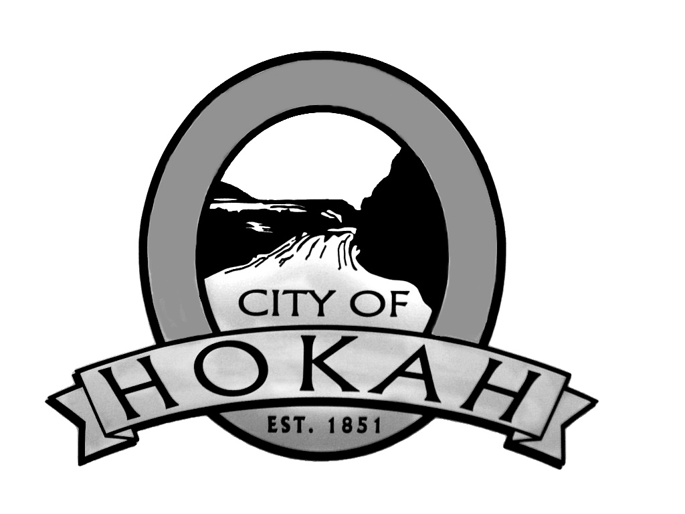
AGENDA
SEPTEMBER 7, 2021 / 6:00 pm
REGULAR COUNCIL MEETING
- CALL TO ORDER:
- PLEDGE OF ALLEGIANCE
- ROLL CALL
- ACTION TO CHANGE AGENDA:
- Consent Agenda:
All items listed under the consent agenda are considered routine by the City Council and will be enacted by one motion. There will be no
separate discussion of these items. If discussion is desired, that item will be removed from the Consent Agenda and will be considered separately.

1.1 Regular Council Meeting Minutes August 3, 2021
1.2 Budget Meeting Minutes August 17, 2021
1.3 Bills Payable Through: September 7, 2021
1.4 Consolidated Balance Sheet August 31, 2021
1.5 FD Fireman’s Dance Temporary Liquor License October 15, 2021
- Library/City Hall/City Center Report:
- Water/Wastewater/City Engineer Report:
- Police Dept./City Attorney Report:
- Emergency Management:
- Streets / Maintenance Report:
- Planning Commission / Zoning Report:
  - Variance Extension Request-Randy & Sandy Munson
  - Zoning Permit 2021-09: Robert Naleid
  - Zoning Permit 2021-10: Jerry Martell
- Recreation Board Report:
- New Business:
  - 2022 Budget – Resolution Adopting Proposed Property Tax Levy
- Old Business:
11. Council Member’s Comments/Community Input:
- Mayor’s Comments:
- Staff Correspondence: Root River Bike Trail Extension
- Correspondence Received:
- Announcements:
- Next Council Meeting: October 5, 2021, 6:00 PM
- Items for next Agenda:
- Adjournment:

